**LAB PLAN FOR OUR PRACTICE CLASSES**

**STEP 1:** INSTALL SQL SERVER 2022 / 2019 / 2017 WEBSITE

PURPOSE: TO STORE DATABASES

**STEP 2:** INSTALL **SSMS** TOOL (SQL SERVER MANAGEMENT STUDIO) BROWSER

PURPOSE: TO DEVELOP / MANAGE THE DATABASES

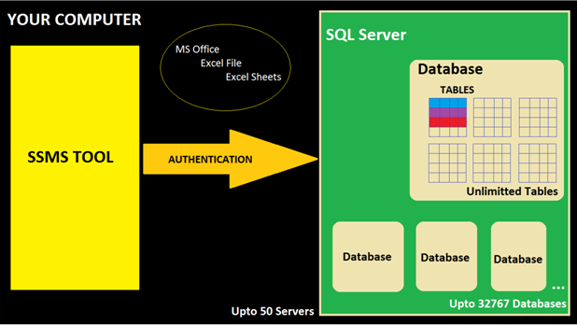

|  |  |  |
| --- | --- | --- |
| **OS REQUIREMENTS** [ANY ONE] | | |
| **VERSION NAME** | **VERSION NUMBER** | **INSTALLATION REQUIREMENTS** |
| **SQL Server 2022 \*** | **16.0** | **WINDOWS 8 OR HIGHER. 64 bit** |
| **SQL Server 2019 \*** | **15.0** |
| **SQL Server 2017** | **14.0** |
| **SQL Server 2016** | **13.0** |
| **HARDWARE REQUIREMENTS** | | |
| **6 GB RAM** | **10 GB DISK SPACE** | **Any Processor that supports Windows OS** |

**SQL Server Installation Plan:**

Step 1: Install **SQL Server** in your computer

Step 2: Install **SQL Server Management Studio** (**SSMS**) Tool

Step 3: Test Connections to your local SQL Server

**STEP 1: SQL Server Installation**

**Screen 1: Download SQL Server 2022 FROM**

[**https://drive.google.com/file/d/1Jw1kkB5qq4VxAdsaknyfiyZ1eDenZVg5/view?usp=drive_link**](https://drive.google.com/file/d/1Jw1kkB5qq4VxAdsaknyfiyZ1eDenZVg5/view?usp=drive_link)

Right Click > Extract.

Then you get one Folder.

Inside the folder >Double Click Setup Application File [Green Icon] :

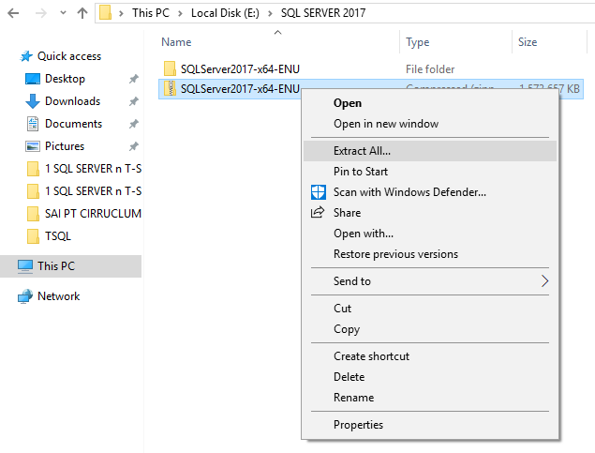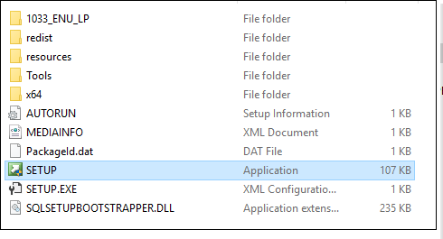

**Screen 2: WE GET “INSTALLATION CENTER” SCREEN >GO TO INSTALLATION PAGE > NEW INSTALLATION**

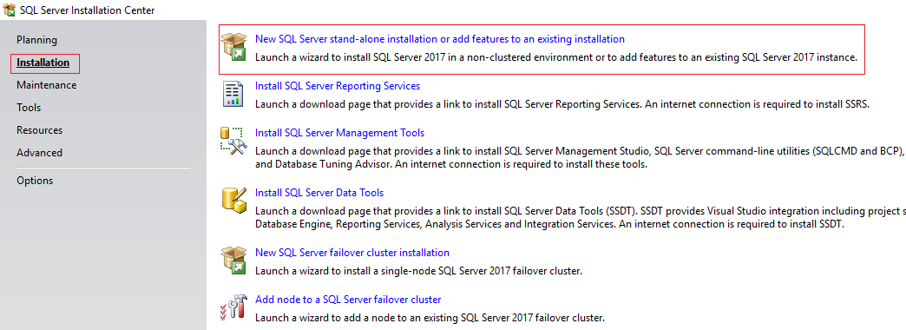

**Screen 3: Click Next > SELECT DEVELOPER EDITION > Accept Licensing Terms > Click Next :**

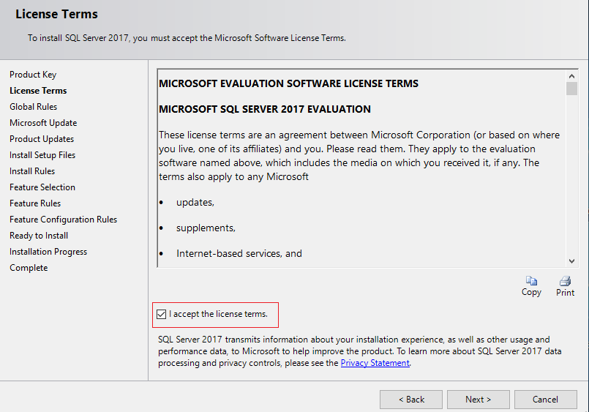

Uncheck **Azure** Extension box

**Screen 4: Click Next > Select Database Engine Component (For OLTP: LIVE, Real-time Data) > Next**

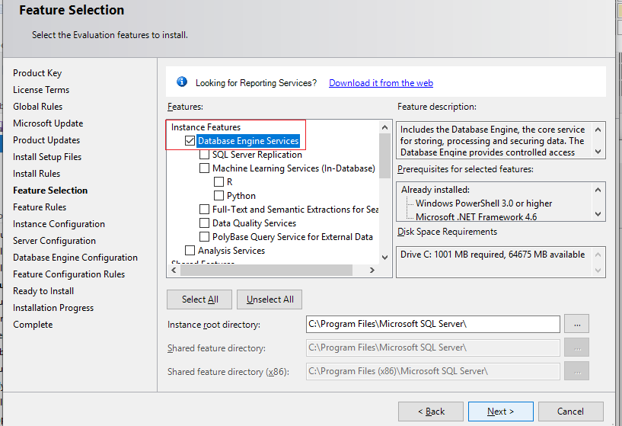

**Screen 5: Specify a Name to your Installation = INSTANCE NAME > Click Next :**

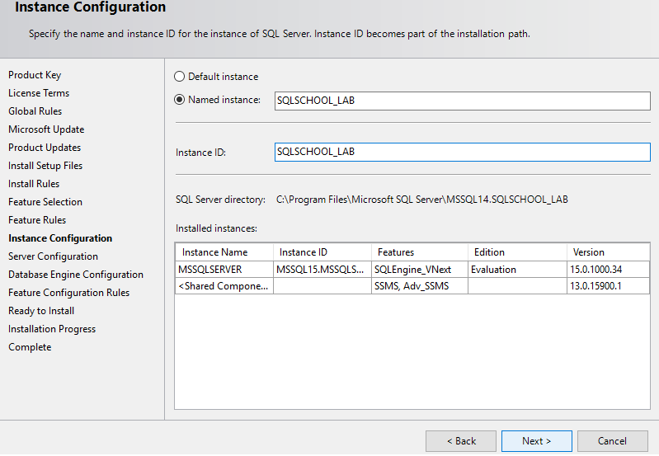

**Screen 6: Click Next > Next > Add Current User as Administrator:**

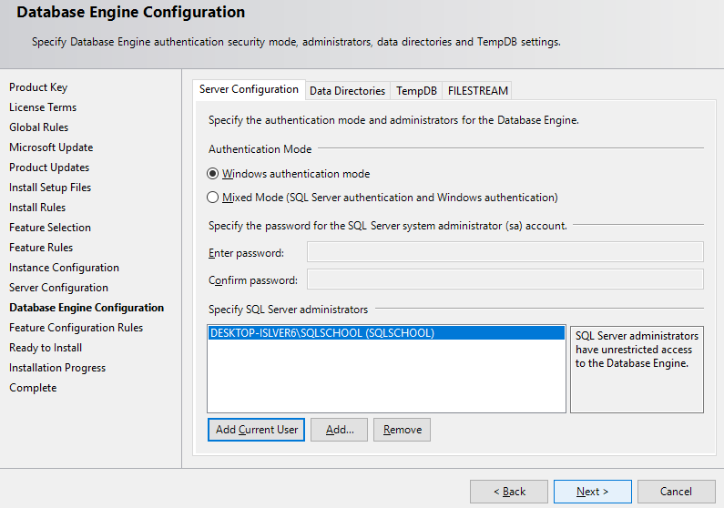

**Screen7: Install**

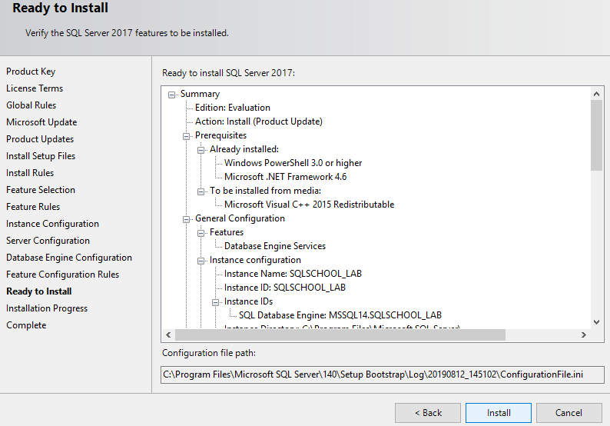

**STEP 2: HOW TO INSTALL SSMS TOOL?**

**SSMS**: SQL SERVER MANAGEMENT STUDIO

**PURPOSE**: THIS FREE TOOL IS USED TO CONNECT TO ABOVE INSTALLED SQL SERVER.

PERFORM DATA STORAGE, RETREIVAL, MANAGEMENT, ETC… USING **SQL**.

JUST LIKE A BROWSER NEEDED TO OPERATE ON A WEBSITE, WE NEED **SSMS** TOOL TO OPERATE ON SQL SERVER.

**Download** SSMS Tool [Either 2019 or 2022] from : <https://aka.ms/ssmsfullsetup>

Double Click the **SSMS-Setup-ENU** File > Install. It would take about 30 to 45 mins.

**Restart your computer.**

After restarting your computer: If you get **REPAIR** screen then **CLOSE** it.

**STEP 3: HOW TO TEST THE INSTALLATIONS ?**

**HOW TO TEST THE SERVER CONNECTIONS?**

WINDOWS APPS > SEARCH > TYPE "**SSMS**" > CLICK > PROMPT FOR SERVER NAME>**BROWSE** FOR MORE >**EXPAND** DATABASE ENGINE >**SELECT** ABOVE INSTALLED SERVER (1) > OK >**CONNECT**.

**Instance:** A successful installation of SQL Server. We can install up to 50 instances per OS.

Each instance has its own (UNIQUE) name. NO space for the Instance Name.

**Types of Instances:** **DEFAULT INSTANCE NAMED INSTANCE**

------------------------------------------------------------------------------------

**Instance Name** MSSQLSERVER Defined during Installation (ex: srv1)

**Server Name**  ComputerName ComputerName\InstanceName

**Databases per Instance** 32767 Databases 32767 Databases

**Port** 1433 Dynamic

**Number of Installations** Up to 1 per OS Up to 50 Instances per OS

**Real-time Usage** Production Development & Testing

**Edition** ENTERPRISE (LICENSED) EVALUATION / DEVELOPER (FREE)

**SYSTEM DATABASES**

DURING SQL SERVER INSTALLATION, A SET OF DATABASES ARE AUTO CREATED.

THESE ARE CALLED **SYSTEM DATABASES**.

ONE SET OF SYSTEM DATABASES ARE AUTO CREATED FOR EACH INSTANCE (INSTALLATION).

1. **MASTER** : USED TO CONTROL CONNECTIONS AND PERMISSIONS TO SERVER.

2. MODEL : USED AS TEMPLATE FOR NEW DATABASES WE CREATE IN FUTURE.

3. MSDB : USED BY ADMINISTRATORS (DBA) FOR REPAIRS & MONITORING.

4. TEMPDB : USED BY DEVELOPERS, DATA ANALYSTS @ TEMPORARY DATA STORAGE.

5. RESOURCE : HIDDEN. USED TO ALLOCATE THE RESOURCES (PROCESSOR, MEMORY)

NEEDED FOR ACTUAL DATABASE OPERATIONS (QUERIES).

**COLLATION**:

A server property to specify language settings. Ex: English, Chinese, Russian... & Case Sensitivity.

**FILESTREAM**:

A server property to store big data and perform analytics. For Azure Cloud &/ Power BI Cloud.